1. Palindrome Checker

A palindrome is a word or phrase that reads the same backwards as forwards, e.g. level, refer.

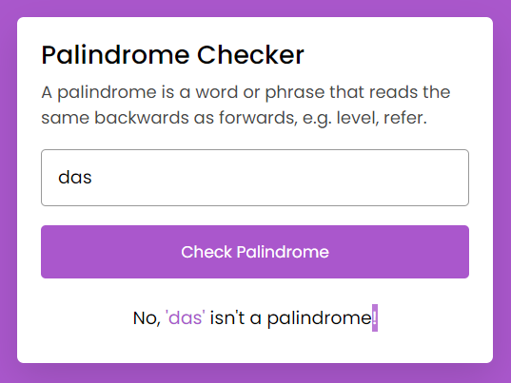

1. Responsive Navbar

Create a navbar for all media query breakpoints using HTML,CSS, Javascript as per below image

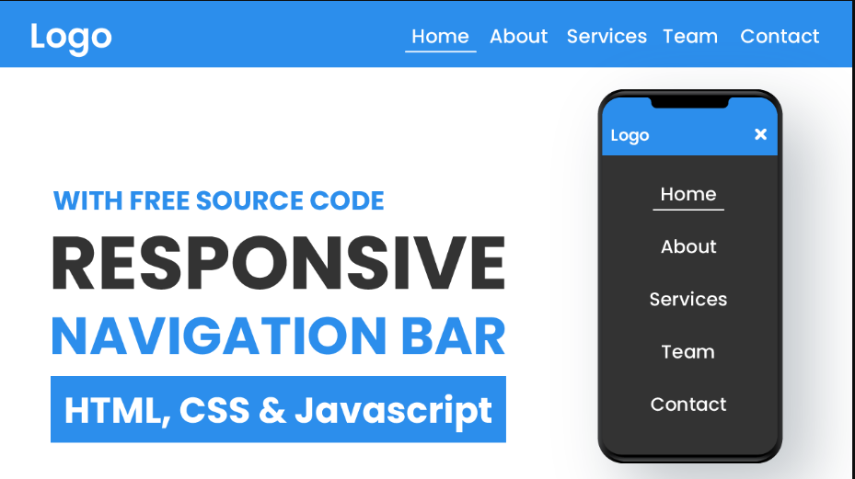

1. Simple Calculator

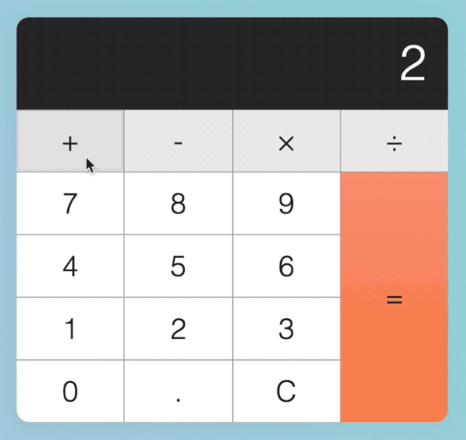

1. Currency converter

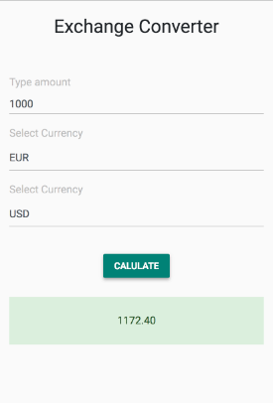

1. Simple Music Player

Following must be done in given below task

Seeker should work Play/Pause music

Next and Prev song

properly

